# **CHAPTER 3**

# **METHDOLOGY**

# **Introduction**

Software Development Life Cycle or Methodology is a process flow of software project. Methodology consist the description about software project which is the details about development project. There are several models of methodology in software development process such as Waterfall model, Agile model, Spiral model, V-Model and Rapid Application Development (RAD). In order to develop FYP Portal, choosing RAD model as methodology can manage the development process and can improve the quality of the project flow. This model focus on prototyping and reuse the existing component will make the requirement deliver rapidly.

# **Rapid Application Development (RAD) Methodology**

The methodology of FYP Portal is Rapid Application Development model. This model use prototypes as functional modules and produce fast product delivery. RAD model suitable with the short time period project. Since RAD model is flexible with requirement changes, it easier to incorporate the changes within the development process because planning not prioritized. The reason RAD be a methodology of this project is:

1. FYP Portal need to be develop rapidly.
2. Involvement of the user in the design and construction phase.
3. Possible to have requirement changes during development.

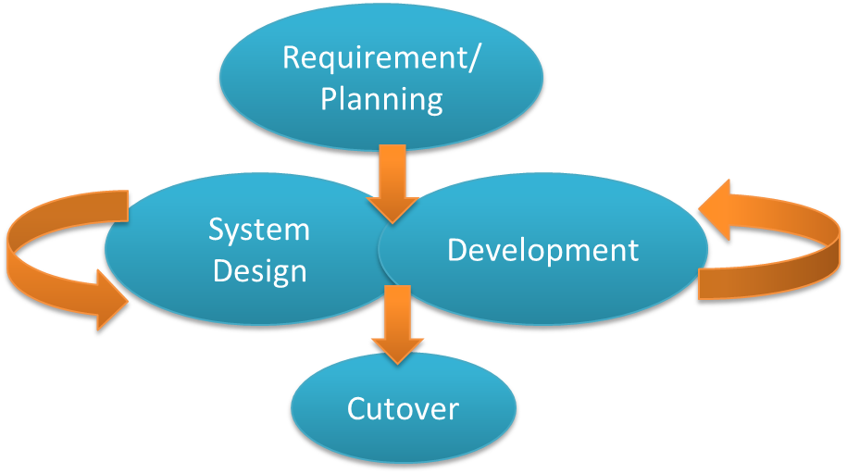

**Figure 3.1 Rapid Application Development Phase**

* + 1. **Requirement Phase**

In Systems Development Life Cycle (SDLC), this phase is a combination of system planning and system analysis. Developer need to comprehended the venture degree and assemble all the necessity and information that should be execute in FYP Portal. Data also can be collect by reviewing the existing system that similar with FYP Portal. The customer and engineer ought to concur on the venture scope and acquire administration approval.

* + 1. **System Design Phase**

Unified Model Language (UML) are being made at this phase. Engineer demonstrate the framework stream for customer by displaying the UML with a specific end goal to help customer comprehend and get a thought regarding this framework. Designer need to correspondence with customer amid advancement a model. This procedure is iterative that enable engineer to change the model until the customer fulfilled.

* + - 1. **Use Case**

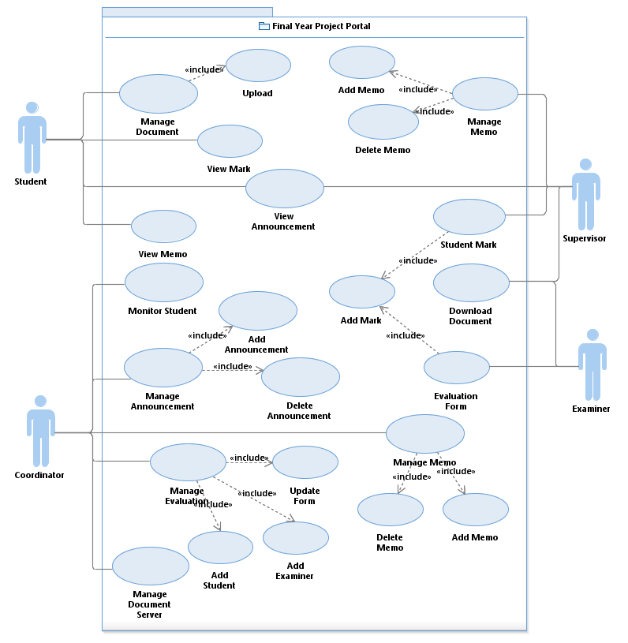

**Figure 3.2 Use Case for FYP Portal**

* + - 1. **Context Diagram**

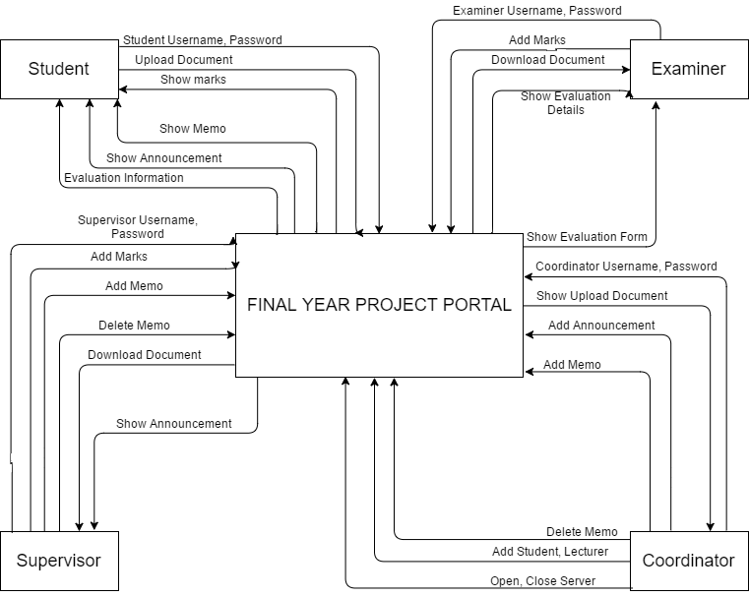

**Figure 3.3 Context Diagram for FYP Portal**

* + - 1. **Dialog Diagram**

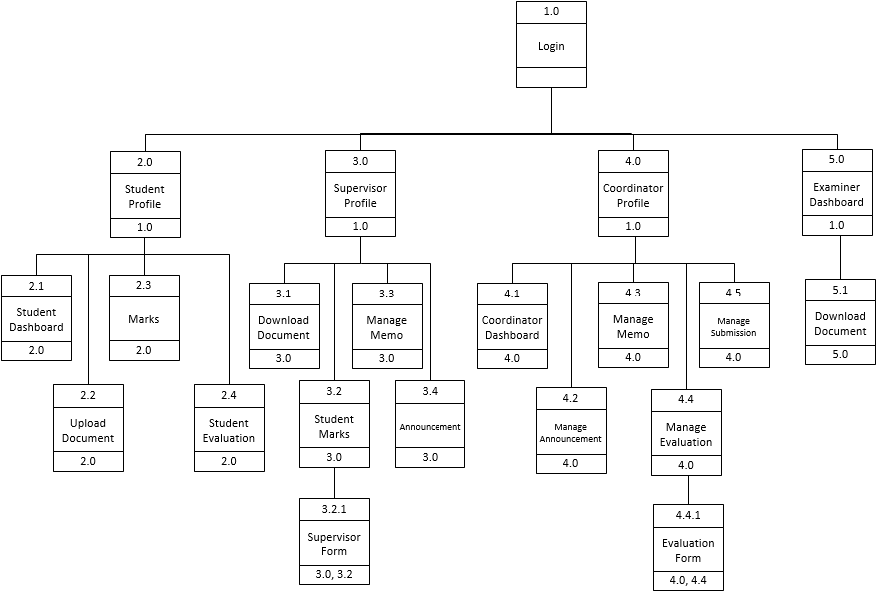

**Figure 3.4 Dialog Diagram for FYP Portal**

* + 1. **Development Phase**

At this phase, FYP Portal focuses on program and application development task similar to the SDLC. In RAD model, users continue to participate and can still give suggestion to changes or improvements as actual screens or reports are developed. The tasks are programming and application development, coding, unit-integration and system testing.

* + 1. **Cutover Phase**

During this phase, it resembles the final task in the SDLC implementation phase, including data conversion, testing, changeover to the new system, and user training. Compared with traditional methods, the entire process is compressed.

# **Hardware and Software**

* + 1. **Software**

Specific software need to be consider before

|  |  |  |
| --- | --- | --- |
| **Software** | **Version** | **Purpose** |
| Windows 7 Ultimate | 64bit Operating System | Operating system that used to manage computer hardware and software by run all program required in order to complete the system. |
| Microsoft Word 2013 | Pro 2013 64bit | One of Microsoft Office application that used to complete a documentation. |
| Microsoft Project 2013 | Pro 2013 64bit | Used to create a Gantt Chart. |
| Rational Software Architect (RSA) | Version 8.5 | Project management software from Microsoft that used to create a UML diagram. |
| XAMPP | Version 5.6.3 (PHP 5.6.3) | An open-source web server package that use to connect the system with the server. |
| Visual Studio 2013 | Ultimate 2013 64bit | A complete set of development tools for building web application system. |
| Justinmind Prototyper | Version 7.4.0 | Application to create an interface of the system |

**Table 3.1 List of Software Items**

* + 1. **Hardware**

|  |  |
| --- | --- |
| Hardware | Description |
| Notebook | Personal computer that used to develop the system and create the documentation of the project. |
| Mouse | Pointing device that use to drack and drop during development an interface. |
| External Hard Disk | External data storage device that use to store a backup of the system and the documentation of the project. |

**Table 3.2 List of Hardware Items**

# **Gantt Chart**

Appendix 1

Appendix 2

# **Implementation**

In Software Development Life Cycle (SDLC), implementation phase is a development stage where developer need to develop the system. Developer should start writing a code to develop a system by following the user requirement.

# **Testing**

After the system completely develop, the system should be tested in order to verify the system follow the requirement. Tester should record or make a report in order to improve the system at maintenance phase.

**APPENDICES**

**APPENDIX 1**

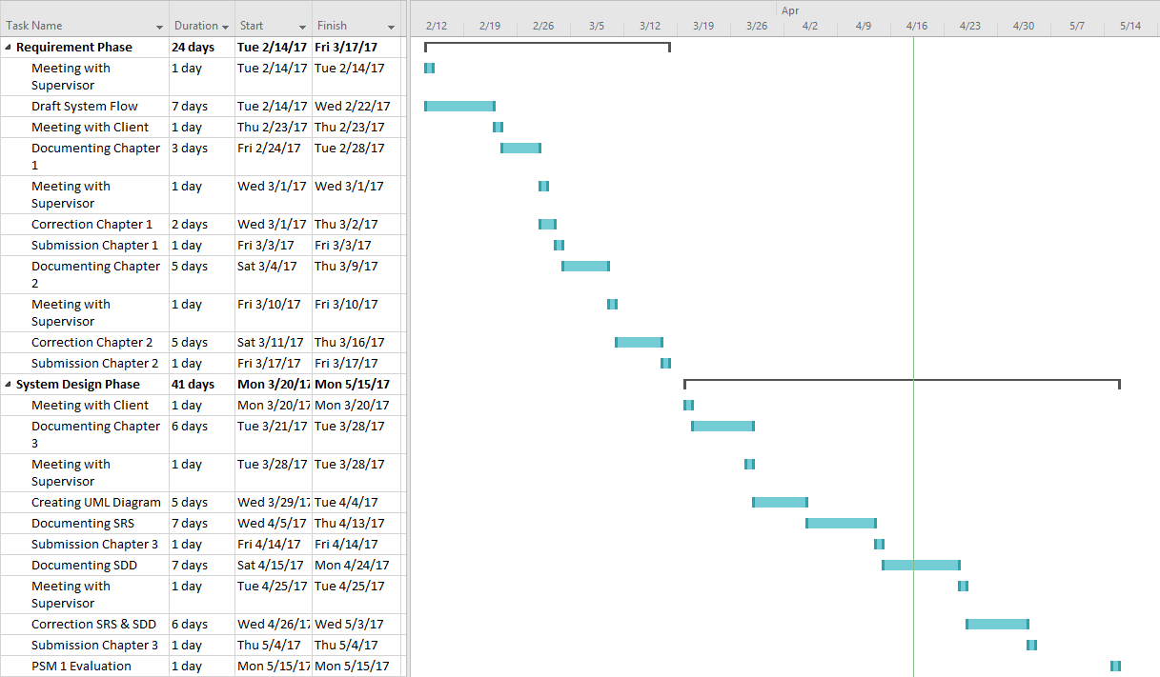

**APPENDIX 2**

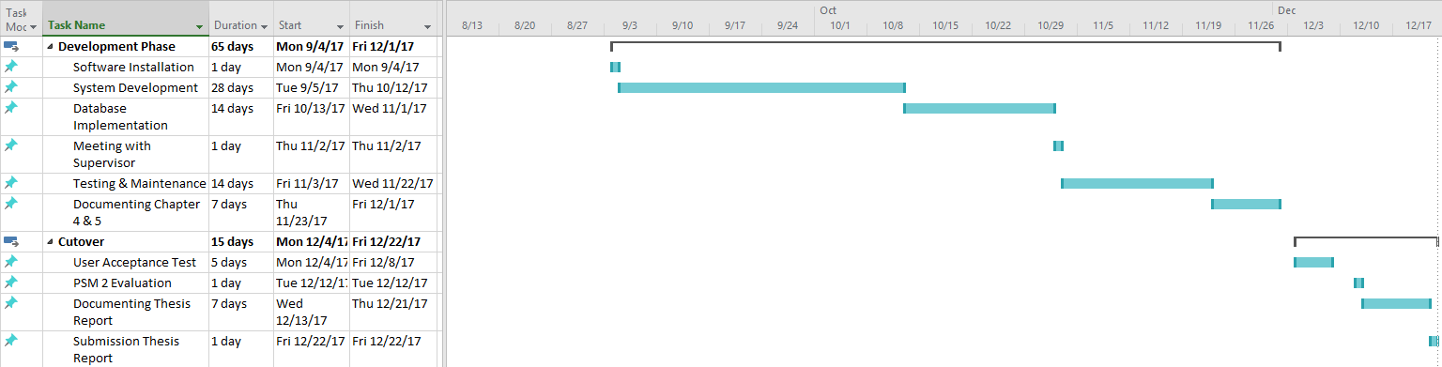

**Version**

**1**

FINAL YEAR PROJECT PORTAL: SUPERVISOR & EXAMINER EVALUATION MODULE

Faculty of Computer Systems & Software Engineering

Software Requirement Specification (SRS)

**TABLE OF CONTENT**

1. **FUNCTIONS 1**
2. **DATA FLOW DIAGRAM LEVEL 0 (DFD LEVEL-0) 3**
3. **DATA FLOW DIAGRAM LEVEL 1 4**
4. **ALGORITHM OR STRUCTURED ENGLISH 9**
5. **DATA MODELLING (ERD) 12**

**LIST OF TABLE**

**Table 1.1: Glossary Table 2**

**LIST OF FIGURE**

**Figure 3.1 Data flow diagram for FYP Portal 3**

**Figure 3.2 Data flow diagram 1.0 (login) 4**

**Figure 3.3 Data flow diagram 2.0 (Student Activity) 5**

**Figure 3.4 Data flow diagram 3.0 (Supervisor Activity) 6**

**Figure 3.5 Data flow diagram 4.0 (Coordinator Activity) 7**

**Figure 3.6 Data flow diagram 5.0 (Examiner Activity) 8**

**Figure 5.1 Entity Relationship Diagram 12**

1. **FUNCTIONS**

|  |  |
| --- | --- |
| **TERM** | **DEFINITION** |
| **Student** | Undergraduate student of Universiti Malaysia Pahang who enrolled final year project. |
| **Supervisor** | Lecturer of Universiti Malaysia Pahang who became an adviser to the students taking final year project. |
| **Coordinator** | Lecturer of Universiti Malaysia Pahang who conduct a Final Year Project course. |
| **Examiner** | Lecturer of Universiti Malaysia Pahang that became evaluator for student during FYP presentation. |
| **Login Verification** | Function to verify user (Student, Supervisor, Coordinator, Examiner) of this system during login into this system. |
| **Student Profile** | Display personal detail of student. |
| **Supervisor Profile** | Display personal detail of supervisor. |
| **Coordinator Profile** | Display personal detail of coordinator. |
| **Upload Document** | Function to manage a document by upload to the system. |
| **Student Dashboard** | Menu interface for student. |
| **Coordinator Dashboard** | Menu interface for coordinator. |
| **Examiner Dashboard** | Menu interface for examiner. |
| **Download Document** | Process to download a document that uploaded by student. |
| **Student Mark** | Process to manage student mark that given by supervisor. |
| **Marks** | Display process where student can see their latest mark. |
| **Manage Memo** | Process to create a memo by supervisor and coordinator to send to the specific student. |
| **Manage Announcement** | Process to publish an announcement by coordinator to student and supervisor. |
| **Announcement** | Process to display an announcement from coordinator. |
| **Supervisor Form** | Process to evaluate student by supervisor. |
| **Manage Evaluation** | Process to manage evaluation by assign a lecturer be the examiner to evaluate student by state a specific time and place. |
| **Evaluation Form** | Form that use by examiner to evaluate student. |

**Table 1.1: Glossary Table**

1. **DATA FLOW DIAGRAM LEVEL 0 (DFD LEVEL-0)**

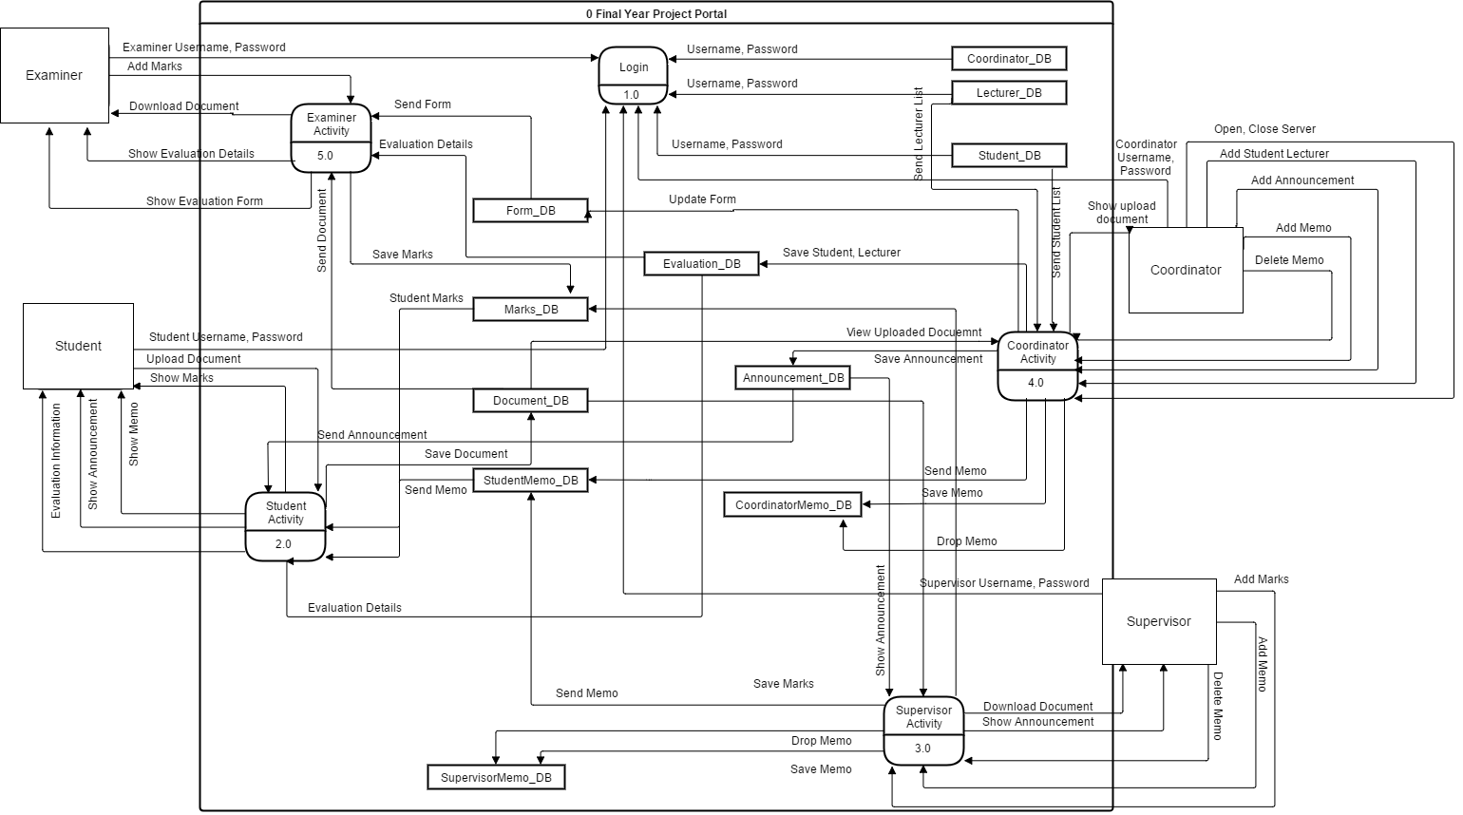

**Figure 3.1 Data flow diagram for FYP Portal**

1. **DATA FLOW DIAGRAM LEVEL 1**
   1. Data Flow Diagram 1.0 (Login)

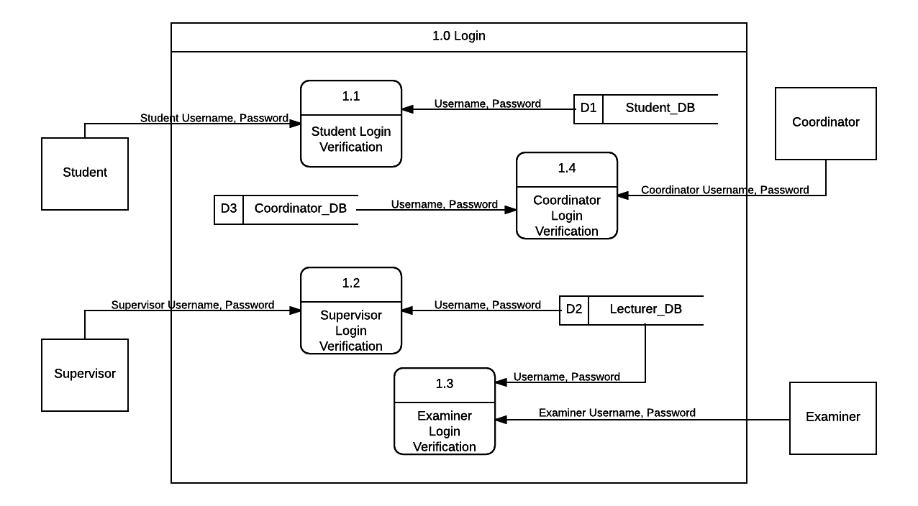

**Figure 3.2 Data flow diagram 1.0 (login)**

* 1. Data Flow Diagram 2.0 (Student Activity)

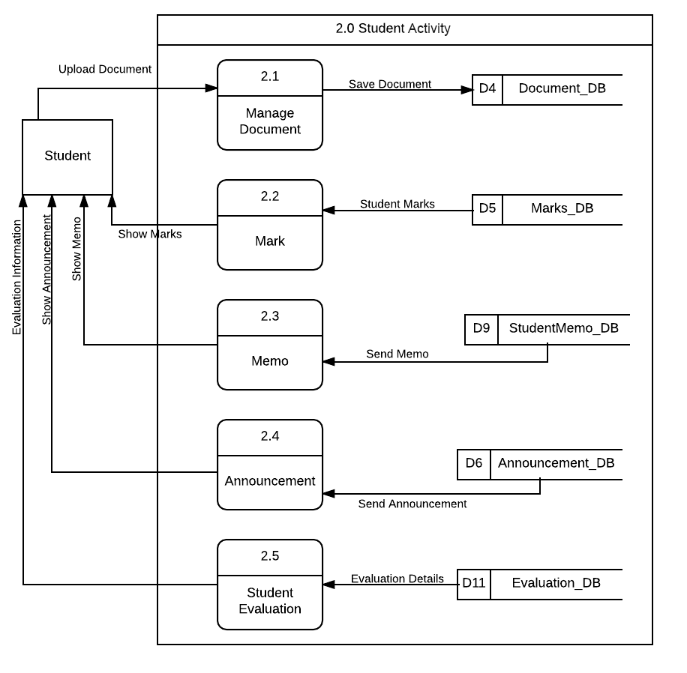

**Figure 3.3 Data flow diagram 2.0 (Student Activity)**

* 1. Data Flow Diagram 3.0 (Supervisor Activity)

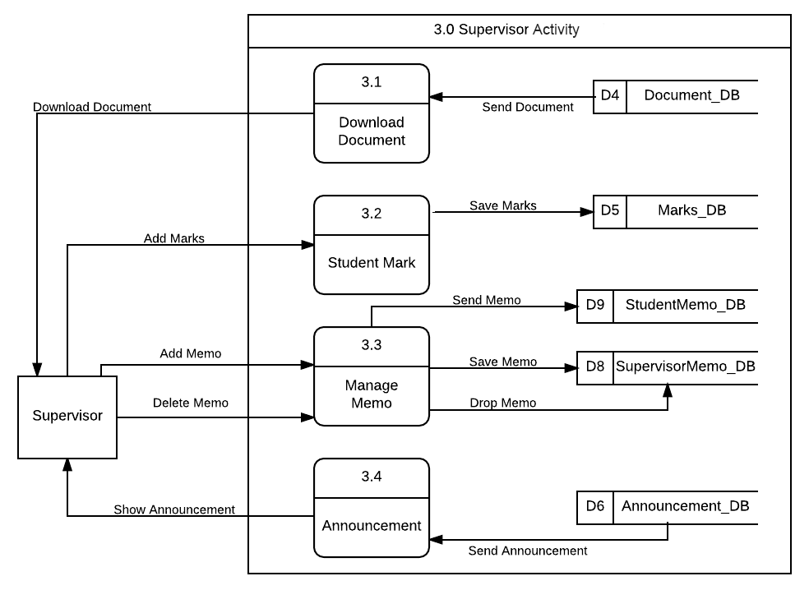

**Figure 3.4 Data flow diagram 3.0 (Supervisor Activity)**

* 1. Data Flow Diagram 4.0 (Coordinator Activity)

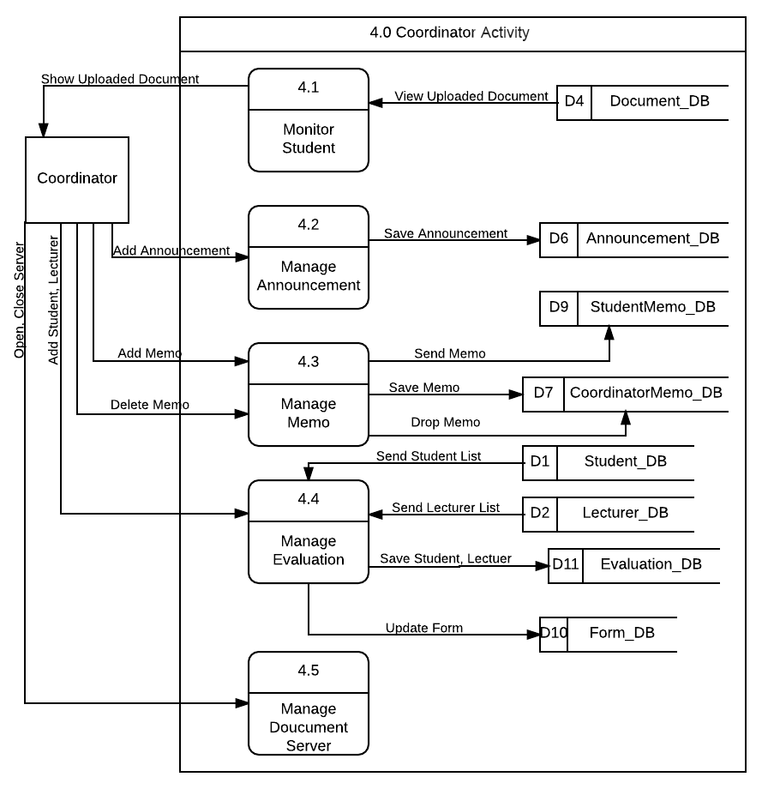

**Figure 3.5 Data flow diagram 4.0 (Coordinator Activity)**

* 1. Data Flow Diagram 5.0 (Examiner Activity)

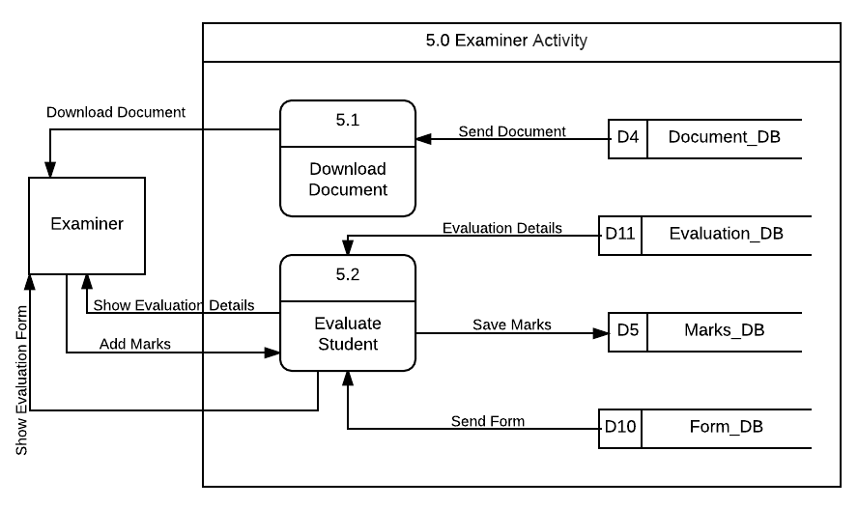

**Figure 3.6 Data flow diagram 5.0 (Examiner Activity)**

1. **ALGORITHM OR STRUCTURED ENGLISH**
   1. **Login**
2. Process start with user need to insert username and password.
3. Before login user need to select login type.
4. Login type consist of student, supervisor, coordinator, examiner.
   1. **User Profile**
5. Is the first interface after student, supervisor and coordinator login to the system.
   1. **Student Dashboard**
6. Process to display announcement and memo.
7. Student can view list of announcement.
8. Student can view personal messages form supervisor and coordinator at memo table.
9. Student can delete a memo.
   1. **Upload Document**
10. Student need to submit their chapter by upload to the system before the submission meet the dateline.
11. Student able to upload the document after the coordinator open the server submission.
    1. **Download Document**
12. Process to download a document that uploaded by student.
13. Supervisor can download a document after student upload the document by chapter to the system.
14. Examiner can download a complete document during evaluation day.
    1. **Manage Memo**
15. Process start with supervisor or coordinator select student name or id first before proceed write a memo.
16. Supervisor only can send a memo to their student under their advice.
17. Supervisor and coordinator can view and delete history of memo that send to the student.
    1. **Mange Announcement**
18. Coordinator can publish the news or announcement by create an announcement.
19. Coordinator need to insert title of announcement and description of announcement before publish to the system.
20. Coordinator can view and delete a history of announcement.
    1. **Manage Evaluation**
21. Process start with coordinator need to select student name first.
22. After select a student, coordinator can select two lecturers to become examiner to evaluate student.
23. To complete the process, coordinator must insert a venue, time and date of evaluation.
    1. **Evaluation Form**
24. Process where coordinator can update form of evaluation criteria.
25. Coordinator can update the description of evaluation by rows.
    1. **Manage Submission**
26. Process where coordinator can open the submission of student document by chapter.
27. Coordinator need to insert the dateline of the submission before open the submission server.
    1. **Coordinator Dashboard**
28. Process to display all student progress and announcement.
29. Coordinator can view student progress by show the statics of uploaded chapter by student.
30. Coordinator also can view all the student including view the status chapter uploaded.
    1. **Examiner Dashboard**
31. Process to display form of evaluation to evaluate student.
32. Examiner need to select student name first before start to evaluate student and give a mark of evaluation.
33. **DATA MODELLING (ERD)**

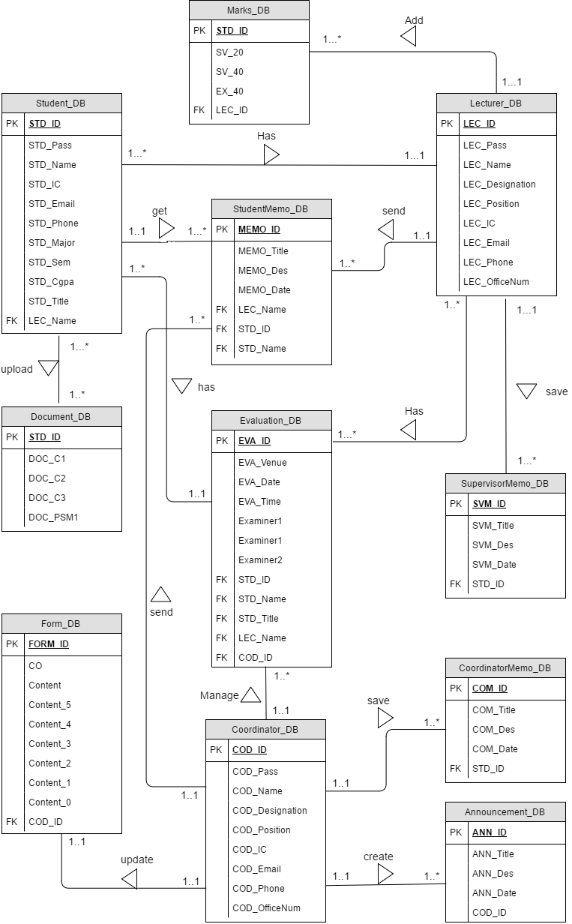

**Figure 5.1 Entity Relationship Diagram**

1. **SYSTEM REQUIREMENTS APPROVAL**

|  |  |  |
| --- | --- | --- |
|  | **Name** | **Date** |
| **Verified by:**  Developer |  |  |
| **Approved by:**  Client |  |  |

**APPENDICES**

**Version**

**1**

FINAL YEAR PROJECT PORTAL: SUPERVISOR & EXAMINER EVALUATION MODULE

Faculty of Computer Systems & Software Engineering

Software Design Document (SDD)

**TABLE OF CONTENT**

**1. DATA DICTIONARY 2**

**2. USER INTERFACE 6**

**3. SYSTEM DESIGN APPROVAL 20**

**LIST OF TABLE**

**Table 1.1 Table of Data Dictionary for Student 2**

**Table 1.2 Table of Data Dictionary for Lecturer 2**

**Table 1.3 Table of Data Dictionary for Coordinator 3**

**Table 1.4 Table of Data Dictionary for Document 3**

**Table 1.5 Table of Data Dictionary for Student Marks 3**

**Table 1.6 Table of Data Dictionary for Announcement 4**

**Table 1.7 Table of Data Dictionary for Coordinator Memo 4**

**Table 1.8 Table of Data Dictionary for Supervisor Memo 4**

**Table 1.9 Table of Data Dictionary for Student Memo 4**

**Table 1.10 Table of Data Dictionary for Form 5**

**Table 1.11 Table of Data Dictionary for Evaluation 5**

**LIST OF FIGURE**

**Figure 2.1 Interface for login 6**

**Figure 2.2 Interface for student profile 6**

**Figure 2.3 Interface for student dashboard 7**

**Figure 2.4 Interface for upload document 8**

**Figure 2.5 Interface for student marks 8**

**Figure 2.6 Interface for student evaluation 9**

**Figure 2.7 Interface for supervisor profile 9**

**Figure 2.8 Interface for supervisor download document 10**

**Figure 2.9 Interface for supervisor insert marks 10**

**Figure 2.10 Interface for supervisor evaluate student. 11**

**Figure 2.11 Interface for supervisor manage memo 12**

**Figure 2.12 Interface for announcement 12**

**Figure 2.13 Interface for coordinator profile 13**

**Figure 2.14 Interface for coordinator dashboard 13**

**Figure 2.15 Interface for manage announcement 14**

**Figure 2.16 Interface for manage memo 15**

**Figure 2.17 Interface for manage evaluation 16**

**Figure 2.18 Interface for evaluation form. 17**

**Figure 2.19 Interface for manage submission 17**

**Figure 2.20 Interface of examiner dashboard. 18**

**Figure 2.21 Interface of examiner download 19**

1. **DATA DICTIONARY**

|  |  |  |  |
| --- | --- | --- | --- |
| **Field Name** | **Description** | **Data Type** | **Constraint** |
| STD_ID | Student unique id | Varchar | Primary key |
| STD_Pass | Password student for login | Varchar |  |
| STD_Name | Name of FYP student | Varchar |  |
| STD_IC | Student identity card number | Integer |  |
| STD_Email | Student email address | Varchar |  |
| STD_Phone | Student contact number | Number |  |
| STD_Major | Student major course | Varchar |  |
| STD_Sem | Student current semesters | Varchar |  |
| STD_Cgpa | Student current CGPA | Double |  |
| STD_Title | Student project title | Varchar |  |
| LEC_Name | Supervisor name | Varchar | Foreign key |

**Table 1.1 Table of Data Dictionary for Student**

|  |  |  |  |
| --- | --- | --- | --- |
| **Field Name** | **Description** | **Data Type** | **Constraint** |
| LEC_ID | Lecturer unique id | Varchar | Primary key |
| LEC_Pass | Password lecturer for login | Varchar |  |
| LEC_Name | Lecturer name | Varchar |  |
| LEC_Designation | Lecturer designation | Varchar |  |
| LEC_Position | Lecturer job position | Varchar |  |
| LEC_IC | Lecturer identity card number | Integer |  |
| LEC_Email | Lecturer email address | Varchar |  |
| LEC_Phone | Lecturer contact number | Number |  |
| LEC_OfficeNum | Lecturer office contact number | Number |  |

**Table 1.2 Table of Data Dictionary for Lecturer**

|  |  |  |  |
| --- | --- | --- | --- |
| **Field Name** | **Description** | **Data Type** | **Constraint** |
| COD_ID | Coordinator unique id | Varchar | Primary key |
| COD_Pass | Password Coordinator for login | Varchar |  |
| COD_Name | Coordinator name | Varchar |  |
| COD_Designation | Coordinator designation | Varchar |  |
| COD_Position | Coordinator job position | Varchar |  |
| COD_IC | Coordinator identity card number | Integer |  |
| COD_Email | Coordinator email address | Varchar |  |
| COD_Phone | Coordinator contact number | Number |  |
| COD_OfficeNum | Coordinator office contact number | Number |  |

**Table 1.3 Table of Data Dictionary for Coordinator**

|  |  |  |  |
| --- | --- | --- | --- |
| **Field Name** | **Description** | **Data Type** | **Constraint** |
| STD_ID | Student unique id | Varchar | Primary key |
| DOC_C1 | Chapter 1 document | Varchar |  |
| DOC_C2 | Chapter 2 document | Varchar |  |
| DOC_C3 | Chapter 3 document | Varchar |  |
| DOC_PSM1 | PSM1 thesis document | Varchar |  |

**Table 1.4 Table of Data Dictionary for Document**

|  |  |  |  |
| --- | --- | --- | --- |
| **Field Name** | **Description** | **Data Type** | **Constraint** |
| STD_ID | Student unique id | Varchar | Primary key |
| SV_20 | Marks form supervisor 20 percent | Double |  |
| SV_40 | Marks form supervisor 40 percent | Double |  |
| EX_40 | Marks from evaluator | Double |  |
| LEC_ID | Lecturer unique ID | Varchar | Foreign key |

**Table 1.5 Table of Data Dictionary for Student Marks**

|  |  |  |  |
| --- | --- | --- | --- |
| **Field Name** | **Description** | **Data Type** | **Constraint** |
| ANN_ID | Announcement id number | Integer | Primary key |
| ANN_Title | Announcement title | Varchar |  |
| ANN_Des | Description of announcement | Varchar |  |
| ANN_Date | Date of announcement | Varchar |  |
| COD_ID | Coordinator unique id | Varchar | Foreign key |

**Table 1.6 Table of Data Dictionary for Announcement**

|  |  |  |  |
| --- | --- | --- | --- |
| **Field Name** | **Description** | **Data Type** | **Constraint** |
| COM_ID | Memo id number | Integer | Primary key |
| COM_Title | Memo title | Varchar |  |
| COM_Des | Description of memo | Varchar |  |
| COM_Date | Date of memo | Varchar |  |
| STD_ID | Student unique id | Varchar | Foreign key |

**Table 1.7 Table of Data Dictionary for Coordinator Memo**

|  |  |  |  |
| --- | --- | --- | --- |
| **Field Name** | **Description** | **Data Type** | **Constraint** |
| SVM_ID | Memo id number | Integer | Primary key |
| SVM _Title | Memo title | Varchar |  |
| SVM _Des | Description of memo | Varchar |  |
| SVM _Date | Date of memo | Varchar |  |
| STD_ID | Student unique id | Varchar | Foreign key |

**Table 1.8 Table of Data Dictionary for Supervisor Memo**

|  |  |  |  |
| --- | --- | --- | --- |
| **Field Name** | **Description** | **Data Type** | **Constraint** |
| MEMO_ID | Memo id number | Integer | Primary key |
| MEMO _Title | Memo title | Varchar |  |
| MEMO _Des | Description of memo | Varchar |  |
| MEMO _Date | Date of memo | Varchar |  |
| LEC_Name | Name sender of memo | Varchar | Foreign key |
| STD_ID | Student unique id | Varchar | Foreign key |
| STD_Name | Student name | Varchar | Foreign key |

**Table 1.9 Table of Data Dictionary for Student Memo**

|  |  |  |  |
| --- | --- | --- | --- |
| **Field Name** | **Description** | **Data Type** | **Constraint** |
| FORM_ID | Form id number | Integer | Primary key |
| CO | CO of question content | Varchar |  |
| Content | Content of evaluation | Varchar |  |
| Content_5 | Description for student get 5 marks | Varchar |  |
| Content_4 | Description for student get 4 marks | Varchar |  |
| Content_3 | Description for student get 3 marks | Varchar |  |
| Content_2 | Description for student get 2 marks | Varchar |  |
| Content_1 | Description for student get 1 marks | Varchar |  |
| Content_0 | Description for student get 0 marks | Varchar |  |
| COD_ID | Coordinator unique id | Varchar | Foreign key |

**Table 1.10 Table of Data Dictionary for Form**

|  |  |  |  |
| --- | --- | --- | --- |
| **Field Name** | **Description** | **Data Type** | **Constraint** |
| EVA_ID | Evaluation id number | Integer | Primary key |
| EVA_Venue | Place for evaluation | Varchar |  |
| EVA_Date | Date of evaluation | Varchar |  |
| EVA_Time | Time of evaluation | Varchar |  |
| Examiner1 | First examiner name | Varchar | Foreign key |
| Examiner2 | Second examiner name | Varchar | Foreign key |
| STD_ID | Student unique id | Varchar | Foreign key |
| STD_Name | Student name | Varchar | Foreign key |
| STD_Title | Student project title | Varchar | Foreign key |
| LEC_Name | Supervisor Name | Varchar | Foreign key |
| COD_ID | Coordiantor id number | Varchar | Foreign key |

**Table 1.11 Table of Data Dictionary for Evaluation**

1. **USER INTERFACE**
   1. **Login**

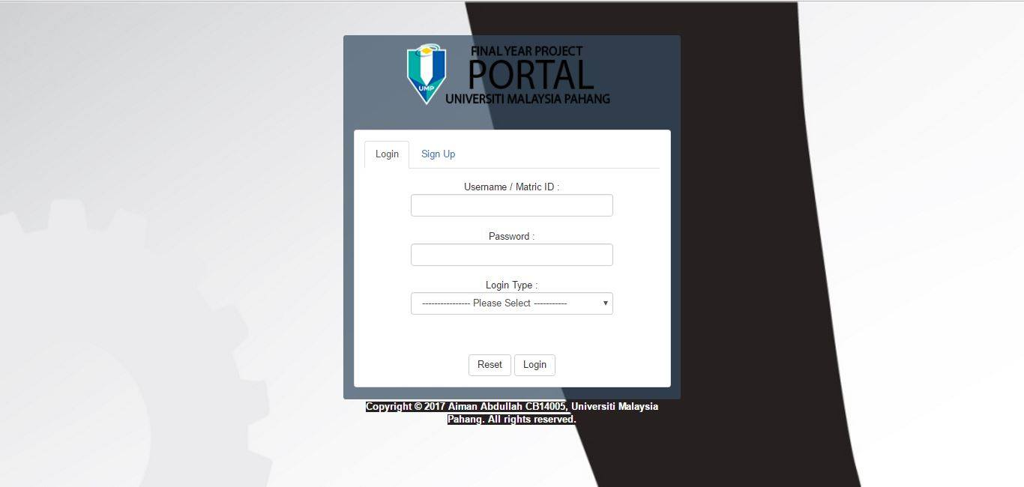

**Figure 2.1 Interface for login**

Figure 2.1 show the interface for user to login before continue using FYP Portal. User need to insert username, password and select the login type either student, supervisor, coordinator and examiner.

* 1. **Student Interface (Student Profile)**

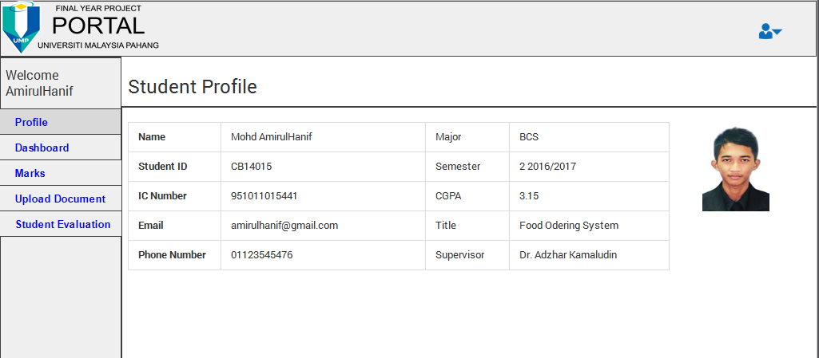

**Figure 2.2 Interface for student profile**

Figure 2.2 show the first interface for student after successful login to the system. This interface shows student profile.

* 1. **Student Interface (Student Dashboard)**

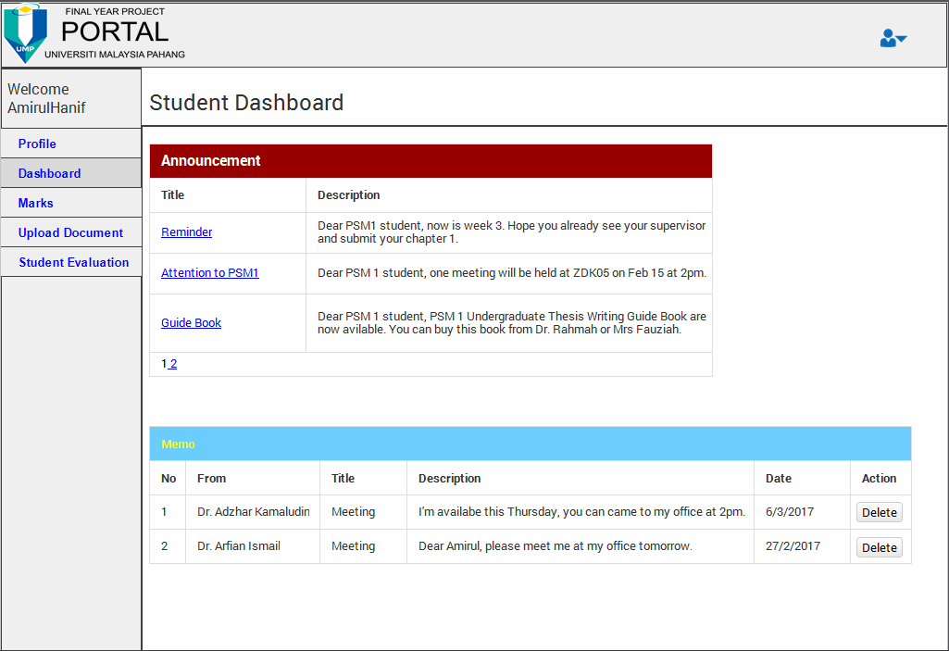

**Figure 2.3 Interface for student dashboard**

Figure 2.3 show the interface for student dashboard. Student can use this interface to view the announcement from coordinator and view a memo from coordinator and supervisor.

* 1. **Student Interface (Upload Document)**

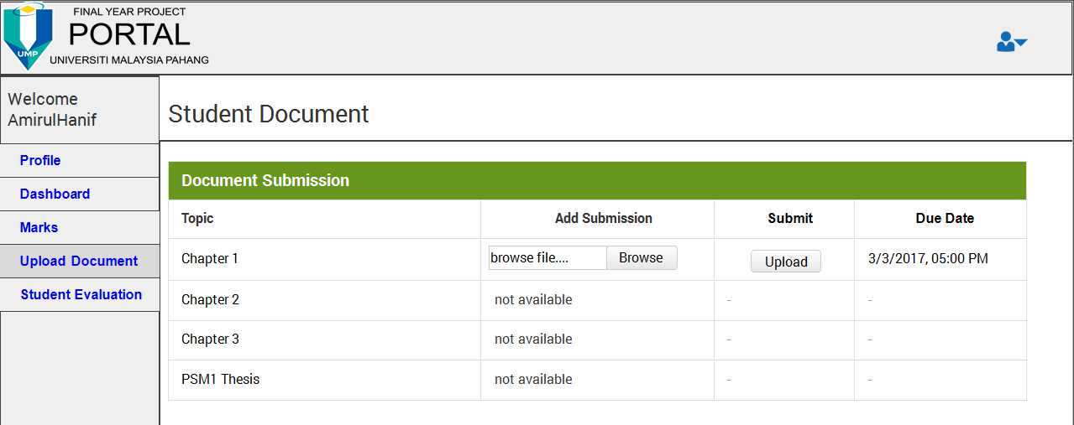

**Figure 2.4 Interface for upload document**

Figure 2.4 show the interface for student submit their document by chapter through this system. Coordinator will open the submission and student need to submit the document before the date line.

* 1. **Student Interface (Marks)**

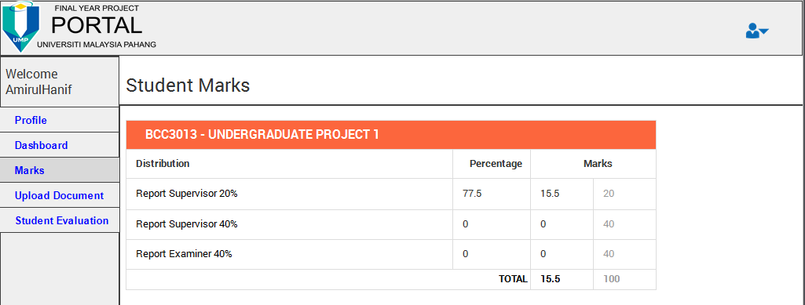

**Figure 2.5 Interface for student marks**

Figure 2.5 show the interface for student view their marks. Marks is given by supervisor twice base on student progress and examiner during the evaluation day.

* 1. **Student Interface (Student Evaluation)**

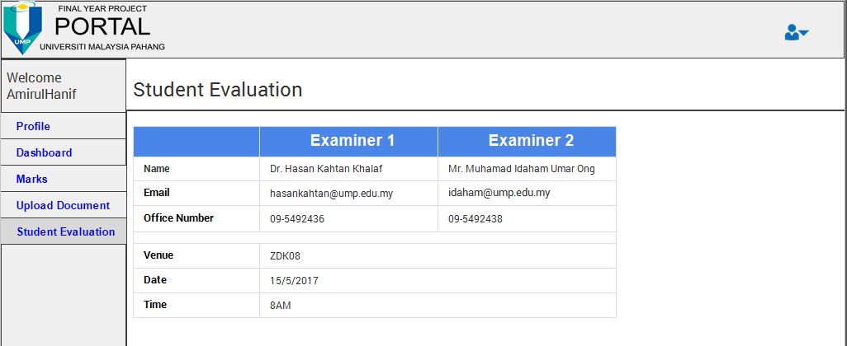

**Figure 2.6 Interface for student evaluation**

Figure 2.6 show the interface for student view their evaluation details and schedule. This schedule was managing by the coordinator.

* 1. **Supervisor Interface (Supervisor Profile)**

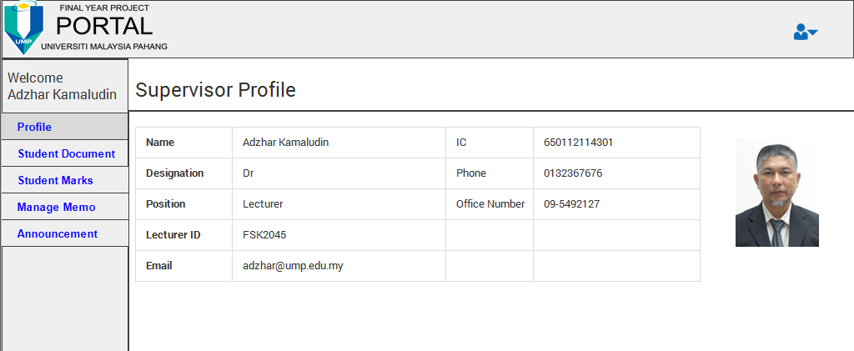

**Figure 2.7 Interface for supervisor profile**

Figure 2.7 show the profile interface for supervisor. Supervisor can view their personal details at this interface.

* 1. **Supervisor Interface (Download Document)**

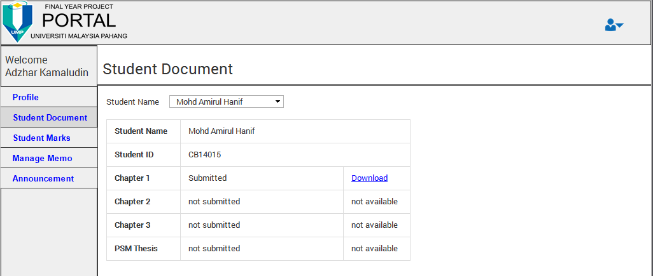

**Figure 2.8 Interface for supervisor download document**

Figure 2.8 show the interface for supervisor download the document that uploaded by their student. Supervisor can select his student name before download the document. The download link only appears after student upload the document through the system.

* 1. **Supervisor Interface (Students Marks)**

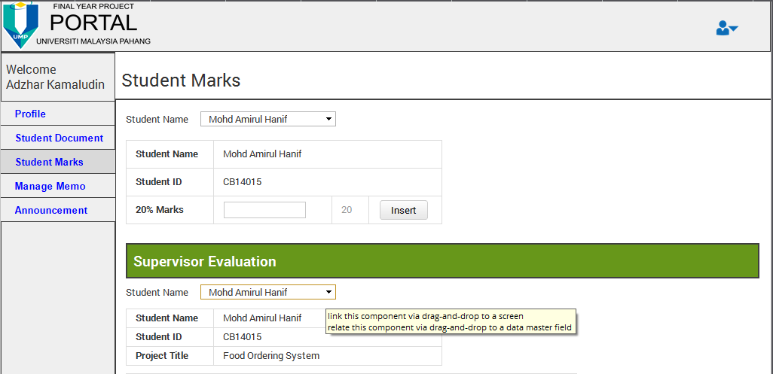

**Figure 2.9 Interface for supervisor insert marks**

Figure 2.9 show the interface for supervisor add his student marks at the first form. Supervisor need to select student name first before add 20percent marks to the student.

* 1. **Supervisor Interface (Supervisor Form)**

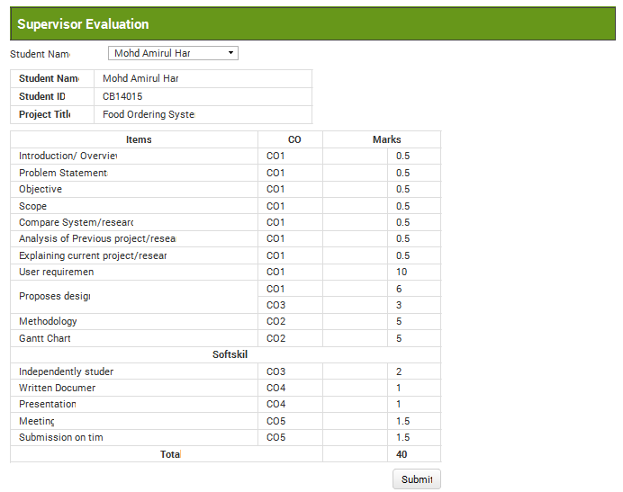

**Figure 2.10 Interface for supervisor evaluate student.**

Figure 2.10 show the interface for supervisor add 40percent marks to his student by using evaluation form.

* 1. **Supervisor Interface (Manage Memo)**

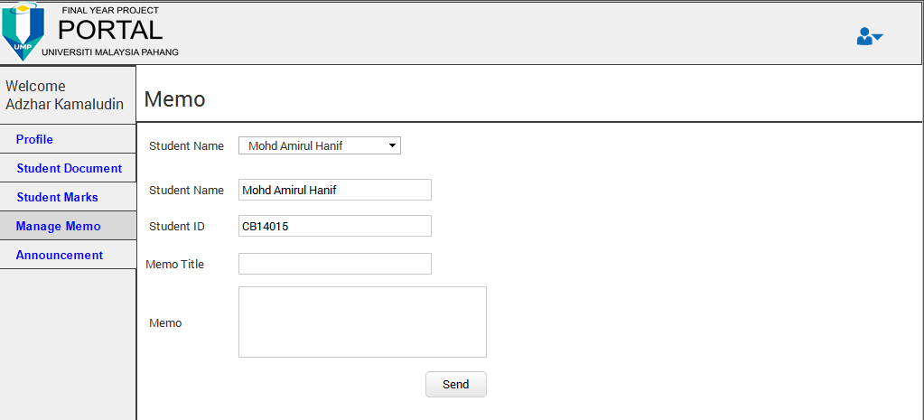

**Figure 2.11 Interface for supervisor manage memo**

Figure 2.11 show the interface for supervisor send a memo to his student. Supervisor need to select student name first before write a memo to the student. Supervisor can state a title of memo and write a memo before sent to his student.

* 1. **Supervisor Interface (Announcement)**

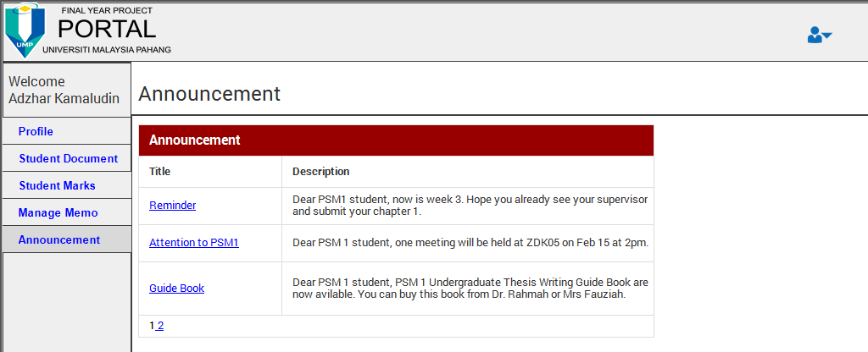

**Figure 2.12 Interface for announcement**

Figure 2.12 show the interface for supervisor view the announcement form coordinator.

* 1. **Coordinator Interface (Coordinator Profile)**

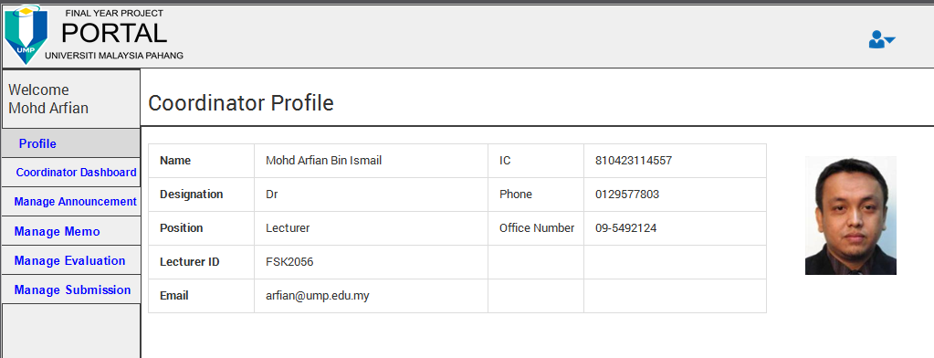

**Figure 2.13 Interface for coordinator profile**

Figure 2.13 show the interface for coordinator after their successfully login to this system. Coordinator can view their personal details at this interface.

* 1. **Coordinator Interface (Coordinator Dashboard)**

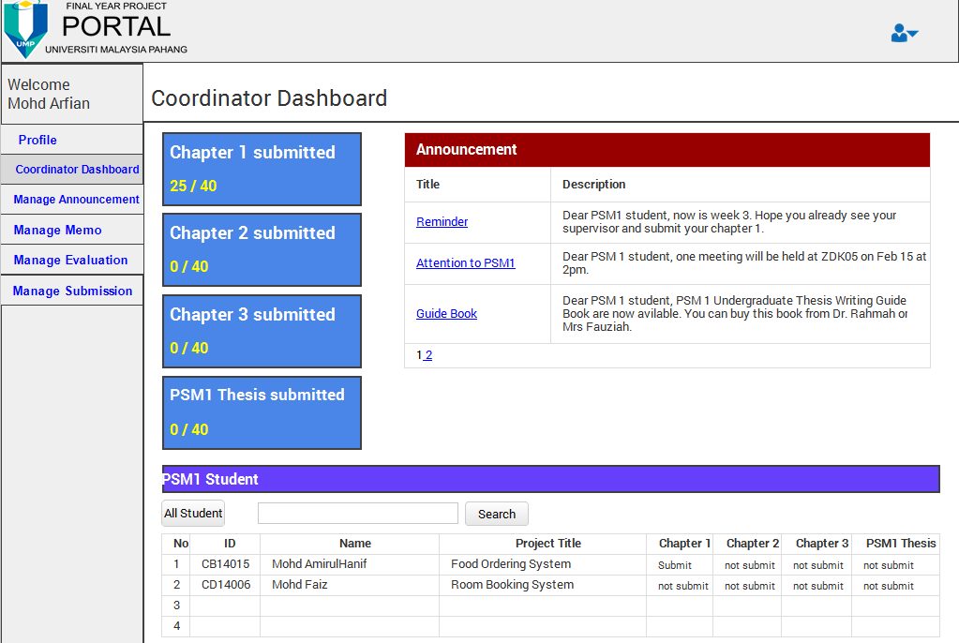

**Figure 2.14 Interface for coordinator dashboard**

Figure 2.14 show the interface for coordinator dashboard. At this dashboard coordinator can view the statistic of student upload a chapter. At the right interface, coordinator can view their announcement. Bottom of the interface was a table that show all student with their progress by upload the chapter. Coordinator can search a student name or id and view the result at the table.

* 1. **Coordinator Interface (Manage Announcement)**

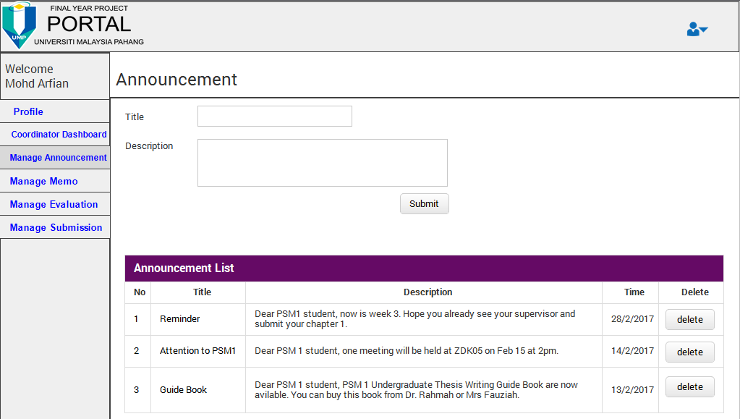

**Figure 2.15 Interface for manage announcement**

Figure 2.15 show the interface where coordinator can create an announcement for student and coordinator. Announcement list is for coordinator view and coordinator can delete the announcement if coordinator want to remove the announcement form the system.

* 1. **Coordinator Interface (Manage Memo)**

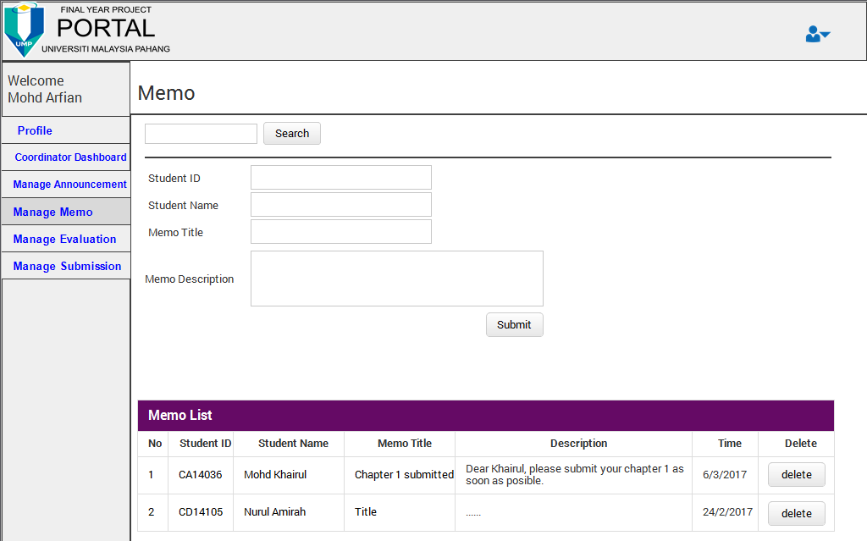

**Figure 2.16 Interface for manage memo**

Figure 2.16 show the interface of coordinator send a memo to student. Coordinator can search student id and student id and student name will appear at text box memo form. Coordinator can send a memo to the student by selected student id. Memo list is a history of memo that create by coordinator and coordinator can deleted a memo if it no longer need.

* 1. **Coordinator Interface (Manage Evaluation)**

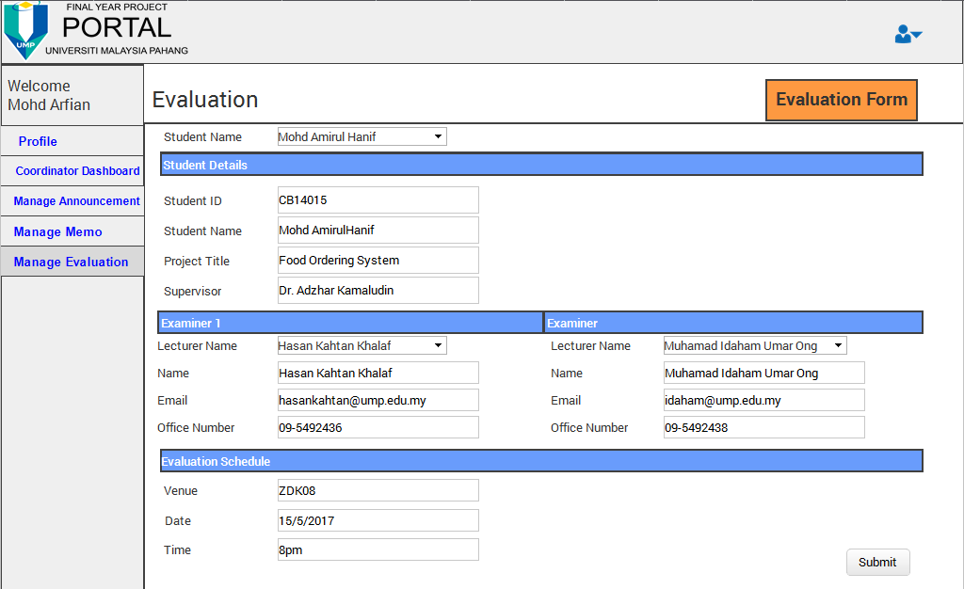

**Figure 2.17 Interface for manage evaluation**

Figure 2.17 show the interface of coordinator can manage evaluation process. Coordinator need to choose student name at dropdown list and student details will appear at the text box. To assign the examiner, coordinator also need to find lecturer name at dropdown list and their details will appear at the text box. To completed a schedule of evaluation, coordinator need to insert a venue, date and time at the form before save to database. At the right top of interface there are link to coordinator view the evaluation form.

* 1. **Coordinator Interface (Evaluation Form)**

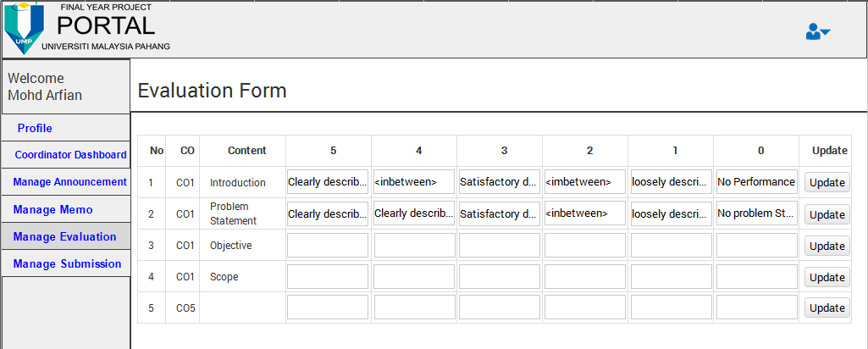

**Figure 2.18 Interface for evaluation form.**

Figure 2.18 show the interface for coordinator update the evaluation form. Coordinator can update the form by rows.

* 1. **Coordinator Interface (Manage Submission)**

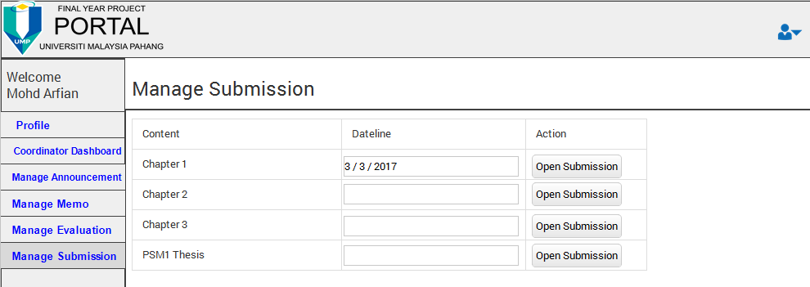

**Figure 2.19 Interface for manage submission**

Figure 2.19 show the interface of coordinator control the submission of student document. Coordinator need to insert the dateline of the submission before open the server for the submission.

* 1. **Examiner Interface (Examiner Dashboard)**

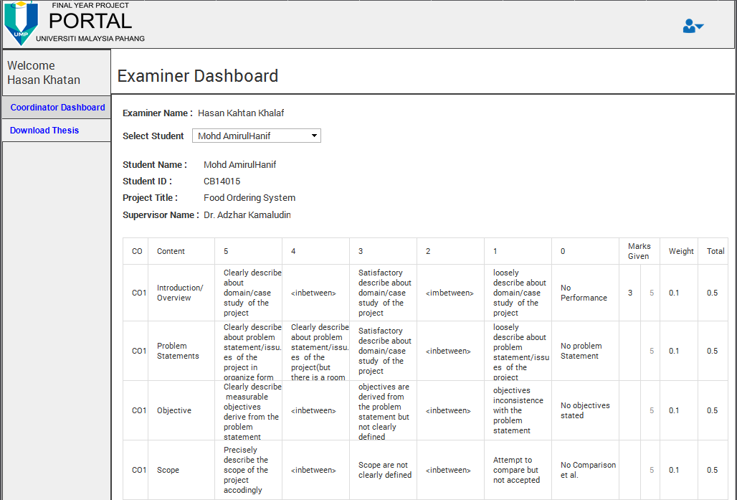

**Figure 2.20 Interface of examiner dashboard.**

Figure 2.20 show the interface of examiner dashboard. At this dashboard, examiner can evaluate student by use the evaluation form. Examiner can select student name that assign by coordinator to evaluate at dropdown list. Student details show after the examiner select a student name. After examiner done evaluate a student, mark from this evaluation will save to student marks.

* 1. **Examiner Interface (Examiner Download)**

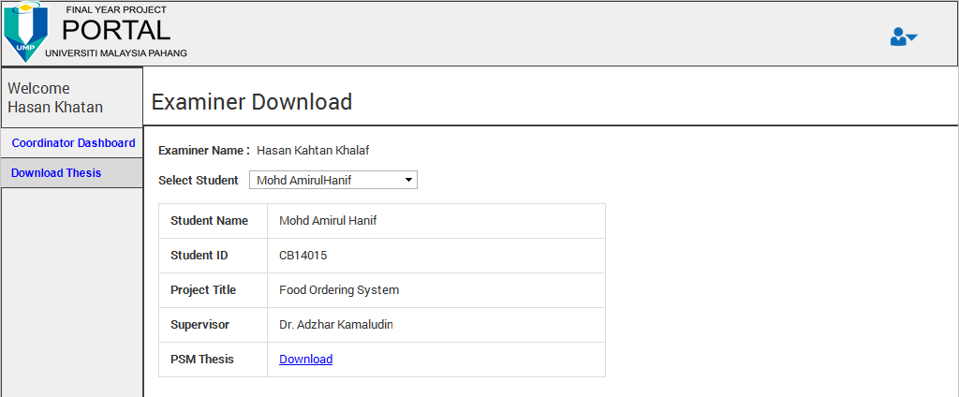

**Figure 2.21 Interface of examiner download**

Figure 2.21 show the interface for examiner download student PSM1 thesis. Examiner need to select student name before download a student thesis.

1. **SYSTEM DESIGN APPROVAL**

|  |  |  |
| --- | --- | --- |
|  | **Name** | **Date** |
| **Verified by:**  Developer |  |  |
| **Approved by:**  Client |  |  |

**APPENDICES**